ASSIGNMENT -6

Using special operators in conditions.

1) Write two different queries that would produce all orders taken on october 3rd or 4th, 1990.
Ans--
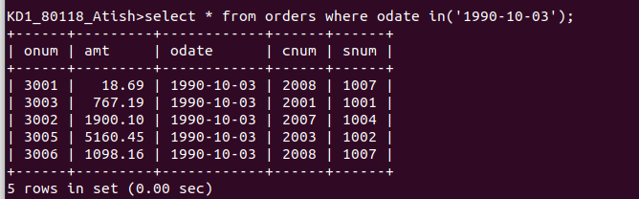

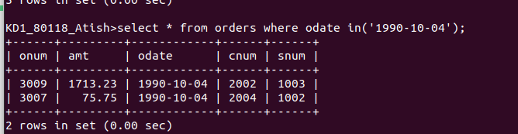

2) Write a query that select all of the customers serviced by Peel or Motika.
Ans--
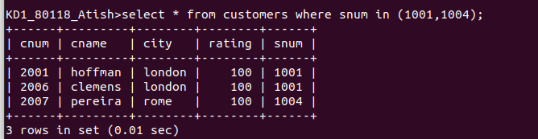

3) Write a query that will produce all the customers whose names begin with a letter from ‘A’ to ‘G’
Ans--

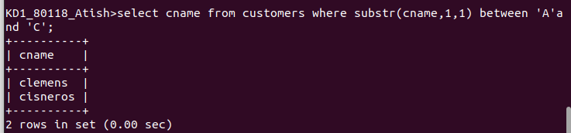

4) Write a query that selects all customers whose names begin with the letter ‘c’.
Ans--
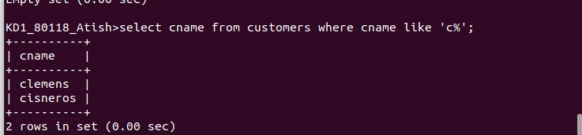

5) Write a query that selects all orders except those with zeroes or NULLs in the amt field.
Ans--
